**How to create Active Directory Users on Windows Server 2019**

**Step1**:First Change the Ip Address of the Machine to static.

Go to the **Server Manager** on your Server.Towards your Right Side you have to go to **Local Server.**under Local Server go to **Ethernet .**Click on IPV4

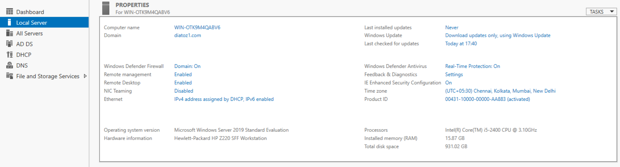

**Step2**:Under Server Manager go to **Add Roles and Features .**under Installation type Select **Role based or feature based installation.**under Server Selection select **select a server from the server pool.**

Under **Server roles** Tick **Active Directory Domain Services**

**DNS Server**

**DHCP**

Say **Next**

**Step 3**:Just Say **Next** and Say **Install**